Integrating Oral Care into Primary Care:
First Tooth
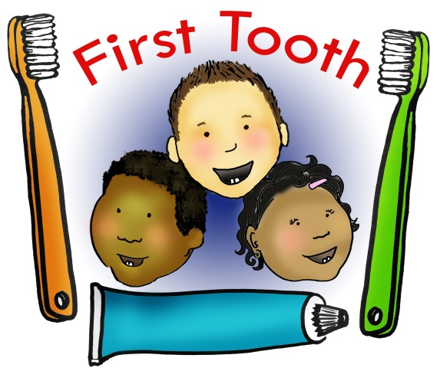
First Tooth is an integration initiative developed to reduce early childhood caries in Oregon by training medical providers to implement preventative oral health services into existing services for infants and toddlers ages five and under. It is also available for WIC programs, HeadStart programs and other entities that have a vested interest in the oral health of children ages 0-5.
Early childhood caries (tooth decay) is a significant public health concern in Oregon and is the most common chronic disease of childhood, affecting five times more children than asthma. Despite its high prevalence, tooth decay is a preventable disease.
The American Academy of Pediatrics and the American Academy of Pediatric Dentistry recommend that babies receive an oral health risk assessment, including a visual screening, anticipatory guidance, preventive strategies, (such as fluoride varnish), and the establishment of a dental home by age one. (Research studies show that application of fluoride varnish can reduce tooth decay between 30% - 69% in primary teeth of high-risk children.)

In order to fulfil these recommendations, First Tooth training topics cover: the prevalence and impact of oral disease, risk assessment, culturally appropriate anticipatory guidance, fluoride varnish application, implementation, workflow tips and access to dental care and a dental home. Trainers also provide on-site support to build collaboration between dental and medical providers.

First Tooth includes:
- 1.5 hour long in-office training for providers and staff on methods of integrating oral health preventative services into current services
- Oral Health Integration Guide, including navigation tools
- Instruction on fluoride varnish application
- Culturally appropriate handouts, exam/waiting room posters and anticipatory guidance that can be shared with parents and caregivers
- Continued support and technical assistance from Oregon Oral Health Coalition (OrOHC) on systems-based implementation, workflow and clinical instruction
First Tooth is one OrOHC’s three oral health initiatives to integrate oral health into primary care across the lifespan. Other resources available are Oral Health and Chronic Disease and Maternity: Teeth for Two.

To learn more about First Tooth and OrOHC’s other initiatives visit orohc.org.
To host First Tooth at your site, contact OrOHC orohcinfo@ocdc.net

